1) Suppose your training examples are sentences (sequences of words). Which of the following refers to the jth word in the ith training example?

a) x(i)< j >

b) x(j)< i >

Answer: a

We index into the ith row first to get the ith training example (represented by parentheses), then the jth column to get the jth word (represented by the brackets).

2) Consider the RNN

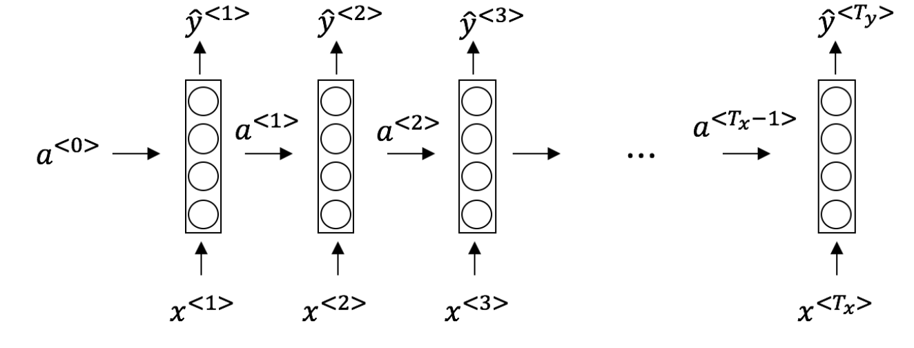

This specific type of architecture is appropriate when:

a) Tx=Ty

b) Tx< Ty

Answer: a

It is appropriate when every input should be matched to an output.

3) **To which of these tasks would you apply a many-to-one RNN architecture?.**

a) Speech recognition (input an audio clip and output a transcript)

b) Sentiment classification (input a piece of text and output a 0/1 to denote positive or negative sentiment)

Answer: b

4) **To which of these tasks would you apply a many-to-one RNN architecture?.**

**a) Image classification (input an image and output a label)**

b) Gender recognition from speech (input an audio clip and output a label indicating the speaker’s gender)

**Answer: b**

**5)You are training this RNN language model. At the ith time step, what is the RNN doing?**

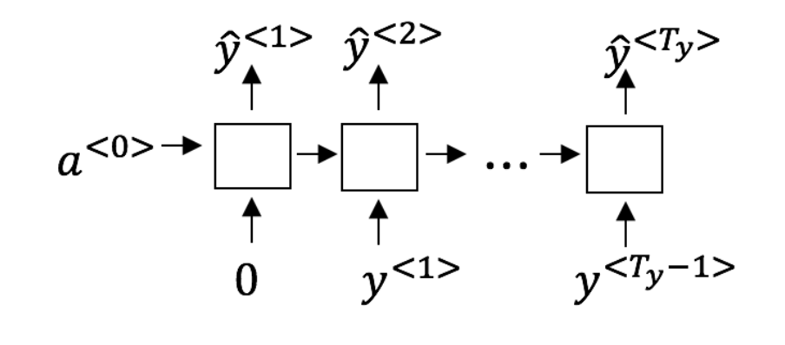

**a) P(y< 1 >, y< 2 >, ..., y< t-1 >)**

b) P(y< t > | y< 1 >, y< 2 >, ..., y< t-1 >)

Answer: Yes, in a language model we try to predict the next step based on the knowledge of all prior steps.

